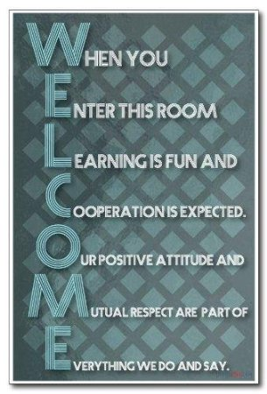
Students in the CORE classroom are expected to:
- try their best
- regularly attend class
- come prepared to learn
  - have supplies
  - keep track of assignments
  - complete homework , research and any prep needed prior to class
  - come with an open mind and be prepared to actively participate
- make good use of classroom time
  - be on time
  - get started promptly
  - listen for instruction (the first time)
  - stay on task
  - ask questions for clarity
  - bring a library book (or other homework if time allows)
  - do not interrupt, wait your turn, be polite and considerate
- complete assignments in a timely manner (expect homework on a regular basis – approximately 20-30 minutes per night per class) Refer to CORE late work policy
- seek make-up assignments upon return and complete in a timely manner (generally one day for each day absent). Please be sure to communicate any special circumstances with CORE staff as they arise.
- contribute equally during group projects and assignments - COLLABORATE
- ask for help when needed – SELF ADVOCATE (before, during, or after class)
- treat others with respect - IN AND OUT OF THE CLASSROOM
  - listen and think before speaking
  - try to see things from a different perspective
  - do not take things without asking
  - wait your turn
  - be willing to give and forgive
  - use kind words and consider “Please”, “Excuse Me”, and “Thank You”
- clean up after yourself – IN AND OUT OF THE CLASSROOM
  - leave the classroom and your desk area neat….even if it was not found that way (this includes the lunch tables and locker area)
  - make sure all electronic equipment is put back where it belongs and charging
  - all classroom supplies should be returned to their proper places
  - store supplies and personal belongings in your locker not in the classroom
- leave food and drinks out of the classroom unless special permission is given, with the exception of a water bottle as needed (NO GUM PLEASE AND THANK YOU)
- adhere strictly to the electronic acceptable use policy
- access computers, cell phones, personal devices only when designated
- comply with school rules and policies in addition to classroom guidelines and expectations
MOST IMPORTANTLY:
- support a safe (social, emotional and physical) learning environment –IN AND OUT OF THE CLASSROOM

Possible Incentives:
- Structured Free Time
- Computer or Electronic Device Time
- Homework/Locker/Restroom Pass
- Drop One Low Daily Grade
- 10 Bonus Points on One Assignment
- Leadership Positions
- Classroom Responsibilities
- Classroom “treat” – must be within healthy food policy
- Coupons for local vendors
- Movie FUN Day
Your suggestion: ____________________________________________________________________
Accountability:
- Loss of the above incentives
- Student Conference
- Peer Conflict Resolution/Solution
- Refocus Form
- Restorative Conference
- Parental Involvement/Conference
- Community Service – before school, at recess, at lunch or after school
- Reflection Center
- Referral to the office for further disciplinary action – Refer to student handbook
Your suggestion: ___________________________________________________________________

I have read the CORE expectations, possible incentives, and accountability. I understand that BRIDGES Charter School is committed to providing a high quality, effective, and standards- based program through the education of the whole child, whereby the individual student is challenged, engaged, supported, healthy and safe. Furthermore, I understand that part of the key to my success will be my commitment to this same belief which includes my dedication to learn and practice conflict resolution skills and collaboration. I understand my responsibility to come to class prepared ready to learn. I also understand BRIDGES has a vison for me to become a lifelong learner and compassionate global citizen. As a member of the BRIDGES community I will do my best to uphold my responsibilities so that I can attain these goals.

Student Signature ______________________________________ Date ________
Parent Signature _______________________________________ Date ________

Don't Be Afraid to Work Hard Enough to Find Out How Good You Can Really Be!

